📘 Types of Homographs
# Source: AI Source: Provided by: [Data Path: Persons Table -> ID Column: 1, Name_En Column: Motasem Essam] -> From: [ChatGPT] on [8/1/2025]
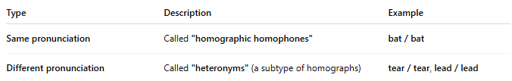
Type | Description | Example
Same pronunciation | Called "homographic homophones" | bat / bat
Different pronunciation | Called "heteronyms" (a subtype of homographs) | tear / tear, lead / lead

